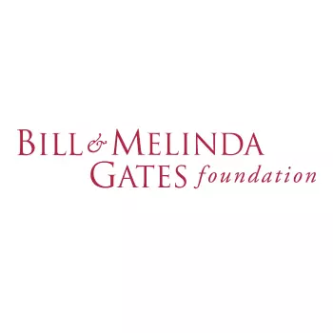**Procurement grant for lab equipment, consumables and reagents**

**Application form**

Please complete all sections of this form. If you have any questions, please contact [support@malariagen.net](mailto:support@malariagen.net). For more information about the grant, [visit our webpage](https://www.malariagen.net/resources/funding-opportunities/procurement-grants-new-funding-opportunity-lab-equipment-specialist).

**Applicant Information**

This is the information about the principal investigator for the application.

| 1. Name |  |
| --- | --- |
| 2. Email address |  |
| 3. Institution |  |
| 4. Country |  |

**Project Information**

This is the information about the project the item(s) will be used for.

| 5. Project title |  |
| --- | --- |
| 6. Countries and locations in which the project operates |  |
| 7. BMGF investment code, if applicable (or Programme Officer name) |  |
| 8. Project start and end date (as set by funder) | Start:  End: |
| 9. MalariaGEN study ID (if applicable) |  |

| **Description of project**  Please provide a concise summary of your project.  250 word limit |
| --- |
|  |

**Budget Information**

This is the summary information for the budget requested. An additional table with a budget breakdown for individual items must also be completed below.

| 10. Item budget requested | **$**  *Please complete the budget breakdown table below. Applications cannot be accepted without a completed budget.* |
| --- | --- |
| 11. Other expected costs (delivery, customs, tax) |  |
| 12. Approximate budget total (USD) |  |
| 13. Customs requirements (e.g. restrictions, special clearance requirements) |  |

**Budget Breakdown and Justification for Resources**

Provide details of specific items requested including approximate costs. If quotes have been obtained please provide these as additional information when submitting the application.

**Budget breakdown table:** (Please state currency e.g. USD $. To support your application, please attach a quote for all items where the individual cost is over $2000)

| Item (please include manufacturer name) | Quantity | Cost per item | Quote attached? (Y/N) | Total |
| --- | --- | --- | --- | --- |
|  |  |  |  |  |
|  |  |  |  |  |
|  |  |  |  |  |
|  |  |  |  |  |
|  |  |  | **Total** |  |

| **Justification of resources**  Please provide a concise justification for the items, including how they will be used to advance the aims of the project and any difficulties you have faced in their procurement.  500 word limit |
| --- |
|  |

Please email your form and budget to [support@malariagen.net](mailto:support@malariagen.net) once complete.